**Windesheim**

Campus 2

Value Chain Rebels

**Jan 29, 2024**

Contents

2. Introduction 5

Purpose of the Action Plan 5

Scope of the Organization 5

3. Executive Summary 6

4. Mission Statement and Objectives 7

VISION 7

Mission 7

Innovate for Financial Sustainability **Error! Bookmark not defined.**

Foster Collaborative Networks **Error! Bookmark not defined.**

Educate and Empower **Error! Bookmark not defined.**

Drive Economic Viability **Error! Bookmark not defined.**

5. Background and Rationale 10

6. Organizational Structure 11

7. Leadership and Governance 11

8. Teams and Departments 12

9. Strategic Plan 13

Core Objectives: 14

Creating Impact 15

10. Operational Plan 23

FASE 1: The startup 23

11. Methodology 24

Inside the Lab 24

12. Budget and Financing 27

Financial Planning 27

Financing Strategies 27

13. Risk Management 28

Risk Analysis 28

Mitigation Strategies 28

14. Marketing and Outreach 29

Target Audience Definition 29

Marketing Strategies 29

Communication Plan 29

15. Evaluation and Improvement 30

Success Metrics 30

Feedback Mechanisms 30

16. Employee Feedback & Action 31

Feedback Collection Analysis 31

Feedback into Action 31

17. Research and Development (R&D) 32

Research Objectives 32

Research Process 32

18. Academic Programs and Curriculum 33

Program Development 33

Teaching Methods 33

19. Student Affairs and Mentorship 33

Student / member Wellbeing 33

Group Activities 33

20. Staff Policies and Faculty Development 34

Recruitment and Retention 34

Professional Development 34

21. Compliance and Regulations 35

Legal Compliance 35

Regulatory Strategies 35

Robust Partnership Networks 39

Innovative Research Infrastructure: 39

Integration of Sustainability Metrics as a solution metric 43

23. ANNEX A 44

Promotion of Labor Practices (in the style of FORD) 53

# Introduction

Placeholder

## Purpose of the Action Plan

Placeholder

## Scope of the Organization

Placeholder

# Executive Summary

Placeholder

# Mission Statement and Objectives

## VISION

Creating more Conscious Supply chains

### Mission

"**Evolutionize** global supply chain dynamics by adding extra value in upcycling and good practices, ensuring that every link in the chain not only benefits economically but also contributes positively to the environment and society.

Revolutionizing global value chains working together with local communities and stakeholders to identify challenges and systemic dilemmas and to conscientiously develop positive and socioeconomical and environmentally beneficial change.

### Foster Collaborative Networks

VCR will combine the strengths and resources of various stakeholders, enabling more effective and innovative solutions to sustainability challenges. This collective approach accelerates systemic change, making it a critical strategy for achieving lasting environmental and social impacts. By working together, organizations can pool their efforts to create solutions that are not only more sustainable but also economically viable, ensuring that the drive towards sustainability is a shared journey, not a solitary endeavor.

* **Action Step**: Establish and nurture collaborative networks that create a **symbiotic** ecosystem, benefiting all stakeholders involved.
* **Goal**: Form a community or network with transparent mutual benefits for each member. This means that we need to publish more, create active polling, and make sure that all our research is open.

### Educate and Empower

By reshaping our understanding and attitudes towards sustainability, it not only prepares us to innovate within the supply chain but also to act as catalysts for broader societal change. This approach is not just about solving current problems but about preventing future ones by embedding sustainable thinking at the core of our decision-making processes. In essence, it's about securing a livable planet for future generations while ensuring equitable access to resources today. Without this shift in mindset, efforts to address environmental and social challenges may remain superficial and short-lived, underscoring the critical nature of education and empowerment in achieving lasting change.

* **Action Steps**:
  + Engage in deep knowledge exploration and innovative learning methods with students, educators, and volunteers.
  + Aim for systemic dependencies by implementing the Patreon system and new agile learning methodologies.
* **Goal**: Build a self-sustaining educational organization focused on sustainability.
* **KPI**: Educate 2,500 individuals by 2028, creating a community that actively supports sustainable practices.

### Drive Economic Viability

to drive economic viability through upcycling supply chains is rooted in the need to demonstrate their comprehensive benefits—not only in terms of social and environmental impact but also from an economic perspective. By evidencing that sustainable practices like upcycling are not merely ethical choices but also financially beneficial, businesses are more likely to adopt these practices.

**Action Steps**:

* + Prove the social, environmental, and economic benefits of upcycling supply chains to businesses.
  + Show, trough simulation and data gathering why sustainability matters.
  + Encourage businesses to adopt upcycling solutions by demonstrating their necessity and economic advantage.
* **Goal**: Produce and disseminate at least 10 detailed case studies and reports that highlight the economic benefits of upcycling practices within supply chains, aiming for a 20% increase in adoption rates among targeted industries by 2028.

Create chains from mere transactional pathways to transformative forces for global well-being.

# Background and Rationale

**Growth Trajectory in the European Market**: The European supply chain management software market is poised for significant growth, with projections indicating a 5.26% increase from 2024 to 2028, culminating in a market value of US$5.61 billion. This trend underscores a growing dependency on digital solutions to bolster supply chain efficiency and resilience, highlighting the fertile ground for VCR's innovative approaches.

**Challenges in Current Logistics and Supply Chain Dynamics**: The landscape of logistics has been marred by unprecedented disruptions, notably in 2020, with a record 27.8% of organizations experiencing over 20 disruptions, a sharp rise from 4.8% in 2019. These disruptions, exacerbated by the pandemic, Brexit, the war in Ukraine, and the decline of the Chinese manufacturing dominance, underscore the urgent need for robust, resilient supply chain solutions. The escalating costs of raw materials, identified by 71% of global companies as a primary threat, alongside the critical demand for rapid delivery, further stress the necessity for innovative, accountable procurement strategies.

**Technological Adoption and Cybersecurity Concerns**: The adoption of technology in managing supply chain disruptions has seen a significant uptick, with over half of the organizations leveraging technology for disruption analysis and supply chain mapping. This digital shift, however, brings its own set of challenges, notably cybersecurity risks, which have surged during the COVID-19 era, affecting 81% of global organizations. The increasing frequency and sophistication of cyberattacks highlight a critical operational challenge for supply chain management, emphasizing the importance of robust cybersecurity measures.

**The Imperative for Sustainability and Efficiency**: The drive towards sustainability is becoming increasingly pronounced, with 82% of companies willing to invest more for zero-carbon shipping options. This shift not only reflects a growing consumer demand for sustainable practices but also aligns with the potential for cost savings and competitive advantage, further supported by governmental and EU regulatory focuses on sustainable logistics.

**VCR's Strategic Positioning in the Netherlands**: The Netherlands, with its strategic location and advanced logistics infrastructure, presents an ideal setting for VCR. The country's logistics sector is expected to grow substantially, offering VCR a prime opportunity to capitalize on its innovative supply chain and logistics solutions. This positioning is bolstered by the broader European market's openness to digital transformation and sustainable practices, aligning perfectly with VCR's mission and capabilities.

# Organizational Structure

Placeholder

# Leadership and Governance

Placeholder

# Teams and Departments

Placeholder

# Strategic Plan

1. het **identificeren**/afbakenen  van een value chain probleem – hoe gaan we dat doen?

Zie “how do we select what to change”

1. Het analyseren van een value chain probleem – hoe gaan we dat doen? – AI engine bouwen – Tool nummer 1 – hoe ziet dat eruit *zie verder beneden)
2. De analyse toetsen – how? – knowledge van de crowd – hoe organiseren we dit? Verandering voor en Na toesten door de “BOTTOM LINE” te meten, en additionele “waarde” te meten in de vorm van commerciele nevel activiteiten.   
   Social media campange en polls voordat de verbeter projecten met bedrijven beginnen.
3. Mobiliseren netwerk van experts op specifiek value chain probleem – hoe? – welke (marketing) tools hiervoor nodig? Nood heel hoog maken – FOMO creeren (hier is hoe je advantage kan nemen van deze nieuwe tool, of wet) – FUD creeren (grote nieuwe wetgeving, kijk uit!) - Bij de oor nemen – Door middel van analyse een rapport schrijven hoe het er echt aan toe gaat.
4. Studenten mobiliseren – hoe? – **Increase the Stake | Increase Agency | Increase the Reward | Increase Realism | Increase confrontation | Roman Patreon Model – Vergeet DOCENTEN mobiliser niet 😊.**
5. 6 maands programma met studenten om te komen tot actieplan – de oplossing aanzetten?

* Studenten *kunnen* joinen voor 6 maanden, maar het mag al eerder, en langer. Studenten joinen de organisatie **EERST** en daarna pas een project. Dit is essentieel en als dit niet het geval is, gaat VCR niet werken, eveneens als alle andere Living Lab en Projecten met studenten initiatieven. Ze joinen, en worden opgeleid, en daarna op projecten in een agile methodiek gezet. (zie operational plan)
* Hoe werkt de opleiding? Mentorship program (roman patreon system), immersive learning (personal leerplan en gewoon uitvoering + actief delen (leerweg en resultaat) op een agile manier. (om de zoveel tijd presenteren wat je geleerd en gedaan hebt).
* Studenten (members) moeten opgeleid worden en de organisatie moet zelf-dragend worden. Studenten kunnen dus ook joinen *alleen maar* om te helpen de organisatie beter te maken. Denk bevoorbeeld dus ook aan stages om de alternatieve media te doen, de process op te zetten. Watch this: <https://www.youtube.com/watch?v=vtIzMaLkCaM&>

If you need futher :aha: moments. We moeten afstappen van het schoolse idee dat er een opdracht is, die moet uitgevoerd worden, en dat er dan studenten komen, en die voeren dat uit. De volgorde is fout, er moet eerst gedacht worden “wat is de mogelijke waarde” en dan pas uitgevoerd worden. Zo niet, dan is Dit dwingend, die leid tot een verlies van autonomie en authentieke motivatie. Projecten zullen letterlijk “sterven” elke 6 maanden. Er zou eventueel doorgang kunnen vinden in de traditionele manier, we hebben het gezien in spark, maar de realiteit is dat projecten vaak opnieuw gemaakt kunnen worden. Kennisoverdracht is ook meestal minimaal, omdat de output geen grote waarde heeft voor de stakeholders, of het is niet duidelijk. Ook kunnen studenten al tijden hun studie erbij komen (zonder dat ze hiervoor studenten punten krijgen, een project hebben of wat dan ook, ze kunnen zoiso meedoen). Denk je echt dat ze dat gaan doen? – zekerweten, sterker nog, het is essentieel, en ik denk dat we veel meer members krijgen op die manier. Denk hierbij aan studenten van andere scholen die wij niet eens kennen, die zich door studenten persoonlijke netwerken zich verspreiden. Het haalt ook het idee weg dat het een verknipt stage-bureau-sweatshop is voor (goedkoop) arbeid is, zoals meeste “living labs, innovatielabs & commerciele hackathons”.

1. Het programma moet leiden tot de vorming van de betrokken studenten als doorlopende motor voor aanpak van het speficieke value chain probleem om het network geactiveerd te krijgen/houden – hoe te faciliteren? – community?

Zie vorig punt: Het is om een organisatie te maken die veranderingen effectief uitvoert, dit betekend dat het nooit “uit” staat. Projecten zouden moeten mogen “sterven” en “opstaan” at will, gebaseerd op behoefte = potentiele value win or loss-prevention in euro (een mogelijke combinatie van wetgeving, it optimisatie, supplychain stabilisatie (op meerdere factoren, denk it-defense maar ook logisieke bewegingen) supplychain finance en nieuwe markten en producten. Sustainability heeft veel kanten, als je het ziet als een ecosysteem. We maken het “gezonder” door de meest winstgevende opties te kiezen, die tezamen ook beter zijn voor het climaat (eu norms) en ethiek (hiervoor memorandum) **.**

### Core Objectives:

* 1. **Strengthening Collaboration for Systemic Impact:** Building a dynamic network of partnerships across academic, industry, governmental, and non-governmental sectors to amplify the adoption of upcycling practices and influence systemic change.

**By creating a consortium of active partners from multiple industries we can create the ecosystem necessary to not just start projects, but to keep them going.**

* 1. **Pioneering Upcycling Supply Chain Solutions**: Innovating at the intersection of sustainability and profitability, developing research-driven insights and practices that optimize supply chain operations without compromising ethical standards or financial outcomes.

**By creating and or gathering upcycling tools, we give logistic companies the opportunity to change**.

* 1. **Empowering Through Education:** Creating a comprehensive **educational ecosystem** that leverages workshops, simulations, and digital resources to equip current and future professionals with the skills and knowledge necessary for implementing upcycling supply chain practices. Giving them the tools to identify challenges within existing SC and find (existing) solutions with local stakeholders in an equitable manner.

**By creating educational material, simulations and training new changemakers, we can scale our impact.**

### Creating Impact

**What do we create? What do we change?**  
At VCR we are hardwired to create “extra value” for supply chains, this is a combination of real demonstratable improvements in efficiency, marked by reduced operational costs and increased throughput and new upcycling opportunities.

* **Living Projects:** VCR is not a commercial enterprise and as such conducts research based on public opinion, with visibility as a key marker. Projects, “evolve”[1] to better themselves over time, measuring impact in supply chains can take long time after all.

## How do we select what to Change?

**The stakeholder analysis:** By identifying who must gain, or lose, or could be affected by a particular supply chain, we can identify the “power” of stakeholders to change the system.

Then we use the align method, see operational plan 11, to make sure the stakeholders are aligned, and the stakes are clear. After this stage, it’s ready to “enter the lab”.

VCR’s stakeholder analysis is more unique than most projects, with VCR we look at the additional **value for the total ecosystem.** This means there are many more stakeholders with every project that was initially foreseen.

**Unique searching methods:**   
We use Reverse OSI, OSI and automatic searching to find additional “signals” of unsustainable supply chains, these are forensics and digital penetration methodologies.

**Timing**: We use agile – scrum methodology for the timing of the project, which means every iteration will be a moment that the project can **stop**.

**Scoping**: We use Agile methodology (See operational plan) we use the align procedure. The output of the students / teachers will need to have value other than “school project”, all stakeholders need to have a clear “stake” or **cannot be allowed** to join into to the project.

This stakeholder analysis can be made with partners trough our networks, but at VCR we will attempt to find additional alternative ways of finding more stakeholders or involved parties.

Like criminals and the police, **the problem might not want to be found**, “Our costumer doesn’t want us to serve him, initially”. Or the “the stakeholders of the problems are not aware of the problem to begin with.”

* **Active National Monitoring:** We actively monitor and search for ineffective supply chains trough environmental impact or upcycling markers.
* **Data Mining and Analysis**: With companies that implement advanced data analytics seeing an average improvement in supply chain efficiency data mining can significantly enhance the identification of hidden stakeholders and inefficiencies.
* **Social Engineering:** Engaging with industry participants through social engineering can uncover critical insights.
* **Digital Footprint Analysis:** discovering valuable partnership opportunities by analyzing the online presence of potential partners, highlighting the effectiveness of digital footprint analysis in identifying indirect stakeholders.
* **Competitive Intelligence Gathering:** Competitive intelligence has been shown to reveal shared stakeholders and innovative practices, with many businesses using this approach to inform their strategic decisions, including supply chain optimizations.
* **Simulation and Modeling:** Supply chain simulations are credited with reducing operational risks, demonstrating their value in identifying stress points and involved stakeholders.

**Monitoring**

VCR can employ information and advanced algorithms to find supply chains as targets, for example by taking a Composite Sustainability Score:   
  
The Composite Sustainability Score (CSS) for each supply chain can be calculated by weighting and summing the normalized scores of the three components:

We can then combine with the an LMM process to create an “A.I research agent” to find specific “target” supply chains and to “establish a baseline”.

There are lots of A.I LLM models to choose from, like Mistral, Lamma, GPT-Neo, GPT-NeoX, GPT-J, BLOOM, GPT-4ch, FairSeq, Private GPT and Hugging Face's Transformers.

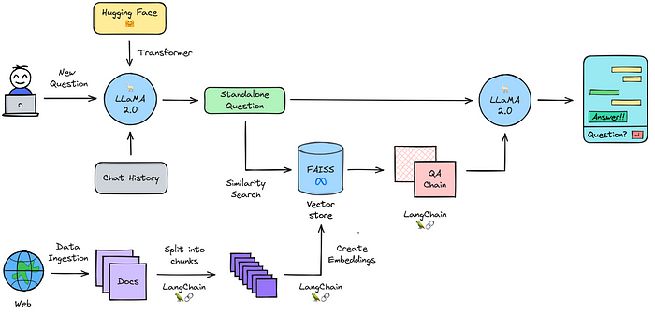

## What does this mean?

the combination of both, the LMM process which creates automatic agents and the algorithm combined allow VCR to “steer” the AI, by making the “weights” of the different values different.

**Hardware Requirements: (ideal)**

* **GPU:** NVIDIA RTX 3080/RTX 3090/A100
* **RAM:** 64GB+
* **Storage:** 2TB SSD

**Software and Libraries:**

* **Python:** Version 3.8+
* **PyTorch:** Version 1.8.1+
* **TensorFlow:** Version 2.4+
* **Hugging Face Transformers:** Version 4.5.0+
* **CUDA Toolkit:** Version 11.1+ (for NVIDIA GPU support)
* **cuDNN:** Version 8.0.5+ (for deep neural network acceleration)

## Open Source Research

We can use “forensics methods” to find and identify specific stakeholders. Using selection criteria, we can “scan” the internet for activists, corporations or institutions.

Using the EDRM model developed by the University of Amsterdam and data processing tools below, we can setup a process that helps identify actors in systems that might, or might not want to be found. The EDRM model is also used in justice systems in all modern court processes in the European union.

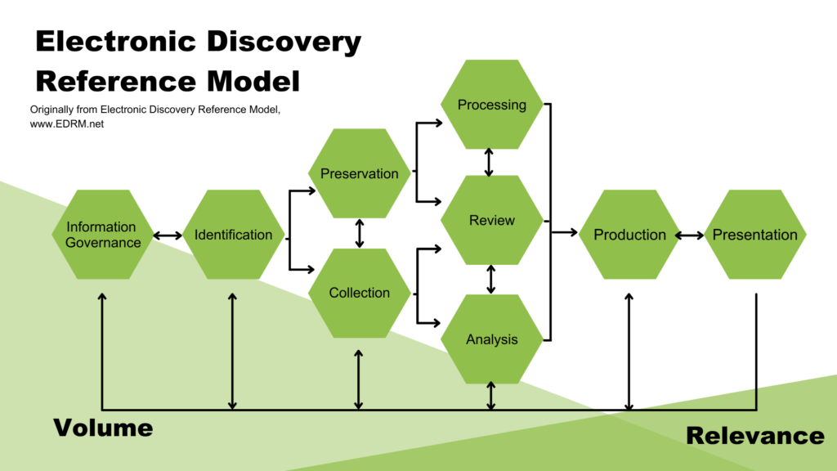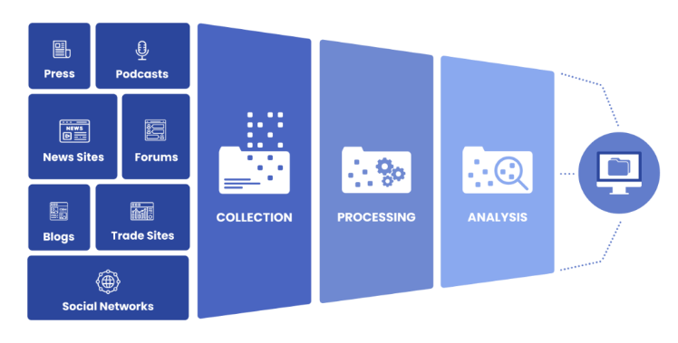

**Software and Tools:**

* **Maltego:** For data gathering and link analysis.
* **TheHarvester:** For gathering emails, subdomains, hosts, employee names, open ports, and banners from different public sources.
* **Shodan:** Search engine for finding specific types of computers connected to the internet using a variety of filters.
* **Metagoofil:** For extracting metadata of public documents (pdf, doc, xls, ppt, docx, pptx, xlsx) available in the target websites.
* **Recon-ng:** A full-featured Web Reconnaissance framework written in Python.
* **OSINT Framework:** Web-based tool for organizing public links useful for cyber-based OSINT investigations.

**Browser Extensions:**

* **FoxyProxy:** For managing and switching between multiple proxy servers quickly.
* **Wappalyzer:** Identifies software on websites.
* **BuiltWith:** Technology lookup tool that allows you to find the technology stacks used by various websites.

**Databases and Online Resources:**

* **Wayback Machine:** For viewing archived versions of web pages.
* **Google Dorks:** Utilizing advanced Google search techniques to find sensitive information or hidden data.

**Analysis and Visualization Tools:**

* **Gephi:** An open-source network analysis and visualization software package.
* **Tableau Public:** For data visualization (there's a free version available).
* **Jupyter Notebooks:** For documenting the OSI process, analysis, and findings in a shareable and reproducible format.

## REVERSE OSI – New development

An new idea by Chris, to reverse the OSI process. Instead of looking for specific actors trough “signals” we can reverse the process, looking at the end result, and then trying to find the actor behind it.

## Reverse OSI – Value & Law

By analyzing the law's requirements—such as due diligence on human rights and environmental impacts—we pinpoint sectors and SMEs with extensive supply chains in high-risk areas. Estimating the compliance cost, particularly for SMEs with 50 employees, highlights those facing significant financial burdens, but this analysis helps us find specific targets that have the highest need for this, even (and especially) if they are not aware.

**Reverse OSI – Research and Thesis**

Using thesis and other research around for example PFAS, we can identify individuals or organizations that are actively trying to research alternative solutions. The thesises should come from “alternative sources” as much as possible, like Stack Exchange for tech, Supply Chain Today for logistics, or Biotech Forums

This method is **already viable right now**, ask chris for demonstration.

**What practical things do we create?**

**Evolution Opportunities:** (Projects, Learnings) the coming together of supply chains and companies, grants and or new upcoming laws. we focus on evolving supply chains with measurable improvements, acknowledging that changes take time and not every attempt leads to success, hence the word “evolve”.

# Operational Plan

## FASE 1: The startup

Finding Opportunities (partnership) An opportunity can be in the form of a grant, or a potential supply chain for improvement. Finding these provides potential funding opportunities as well as potential partners selection criteria. Meanwhile we can start looking for potential partners.  
Starting the Lab: Setting up the minimum infrastructure to onboard potential members into the project.

Starting the tools: Creating materials that we can send to others, that highlight the potential of VCR.

Partnerships is the VCR Network: It’s about identifying stakeholders, and funding opportunities.

The main role of the Partnership group is to **grow and sustain** the VCR community.

Lab is the actual creation of projects: It’s the core of VCR, it’s where students are transformed into changemakers, it’s where new projects are started and monitored.

Tools is the support needed for VCR and it’s stakeholders to function, media, outreach, main infrastructure.

To get an idea of what the Value Chain Rebels onboarding could look like:

<https://www.notion.so/Getting-Started-6668f218d1ae456b8de53cffc3661607>

Example; <https://www.notion.so/HecThaFood-Heck-tha-Food-Home-Dashboard-e7636673ad8f45db8990314fd20b1bfe?pvs=4>

# Methodology

For project initiation, it is crucial that we highlight the potential change that this could bring. We are also working with more traditional partners in a traditional industry so we need to produce information (like this document) in a way that they can expect it. VCR recommends as such the combination of Waterfall updated with Agile principles, as suggested by <https://fka.com/agile-instructional-design/>

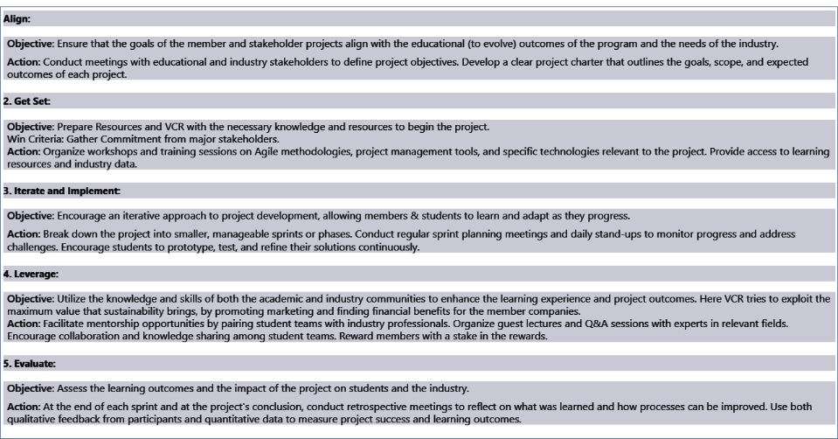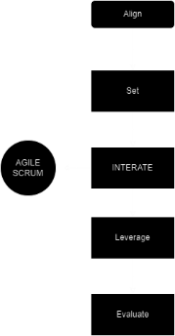

### Inside the Lab

This is the “iterate stage” expanded below.

* **Iterative Development**: Quick sprints allow for continuous improvement and adaptation, ensuring projects stay focused on adding supply chain value. At every sprint, the major stakeholders can decide to “pull the plug”. Members commit on a per-sprint basis.
* **Stakeholder Engagement**: done trough the P.O, in Planning and trough the Review.
* **Product Owner Role**: Defines the vision and prioritizes tasks to maximize supply chain value, setting priorities.
* **Scrum Master Role**: Facilitates the Scrum process, this is a regular member of the team, and extra responsibility**, not a separate role.**
* **Team Members**: Execute tasks based on their diverse expertise, collaboratively driving innovations that add value to the supply chain. Members commit to the tasks they feel comfortable that they can complete at the Sprint planning, which is with the **P.O for questions only.**

**Overall Project Flow**

**(All the different machines in the project)**

Onboarding & Offboarding

Finding Partners

Stakeholder Analysis

Mutual Benefits analysis

Engagement Plan per potential partner

Networking Events

Hackathons

Social Media "phishing"

Reverse OSI - THESIS

Social Media Analysis

Patreon Network

Global Monitoring

Partner Agreements

Collaborative Projects

Collaborative Investment

Co-Create Research Agendas

Real World Testing

| Every AGILE SCRUM CYCLE: PLANNING - EXECUTING - PRESENTING - FEEDBACK

FINDING

Reverse OSI - GRANTS

SELECTING

GETTING

# Budget and Financing

Placeholder

## Financial Planning

Placeholder

## Financing Strategies

Placeholder

# Risk Management

Placeholder

## Risk Analysis

Placeholder

## Mitigation Strategies

Placeholder

# Marketing and Outreach

Placeholder

## Target Audience Definition

Placeholder

## Marketing Strategies

Placeholder

## Communication Plan

Placeholder

# Evaluation and Improvement

How do we guarantee projects survive? That we improve? That we have a good reason to excist?

## Success Metrics

Placeholder

## Feedback Mechanisms

Improvement Process

# Employee Feedback & Action

How do we make sure that feedback is implemented? This chapter might seem irrelevant, but since VCR requires its members to do a lot of volunteering and activities out of passion, making sure that people are heard is of high importance.

## Feedback Collection Analysis

How, and when do we collect feedback?

## Feedback into Action

How do we make sure people are heard?

# Research and Development (R&D)

How are projects found? Which Projects are selected? And why? How is an effective solution guaranteed?

## Research Objectives

How will we know if we are successful?

## Research Process

Which methodology? What are the flows in the organization?

# Academic Programs and Curriculum

How do we serve the larger educational institutions? Which workshops are there? How do we train new members?

## Program Development

How do we create new Workshops and Training material?

## Teaching Methods

Which underlying methodology do we use?

# Student Affairs and Mentorship

How do we know that we complete good internships for students or other members that are coming here to learn? How do we do the paperwork? How do we keep in touch?

## Student / member Wellbeing

How we check if people are not feeling left out?

## Group Activities

Which group activities should we do to promote both fun and learning?

Example: Wolven: A game made to illustrate an informed minority will almost always win against a uninformed majority – Social Dynamics game that explains why “no one is dealing with the climate crisis”.

# Staff Policies and Faculty Development

Placeholder

## Recruitment and Retention

Placeholder

## Professional Development

Placeholder

# Compliance and Regulations

## Legal Compliance

GDPR compliance, ISO 27000

## Regulatory Strategies

How do we make sure that we can keep eachother private and still try to “look” for people.

ANNEX 2 :

**Value Chain Rebels** is an **unique** research lab as it has a **different value proposition:** Unlike commercial labs that often prioritize immediate profitability, potentially sidelining long-term sustainability, and university innovation labs hindered by funding limitations for groundbreaking projects, Value Chain Rebels redefines the game. We champion sustainabe impact as both a core valueand a catalyst for funding, a catalist for recruitment and social media as well as competative business advantage. **Focusing on** the pursuit of **immediate**, **impactful actions** for a upcycling future. This approach not only differentiates us but also drives our mission forward, leveraging short-term sustainability impacts as a strategic advantage.

* **Active National Monitoring:** We actively monitor and search for inneffective supplychains trough environmental impact or unupcycling markers[2]. This helps us select potential sectors for improvement, partners to engage with, and measure impact. Additionally we actively monitor for opportunities, like grants in combination with the partners that have joined our initiative.
* **Living Projects:** VCR is not a commercial enterprise and as such conducts research based on public opinion, with visibility as a key marker. Projects, “evolve”[3] to better themselves over time, measuring impact in supplychains can take long time after all.
* **Agile-Fast Pased Development:** At Value Chain Rebels we work try to maximize short-term upcycling impact, like we’re developing the next million euro application.
* **Sustainability as an Unfair Advantage:** At Value Chain Rebels, we believe in leveraging sustainability as a distinct competitive edge. **We actively explore opportunities rather than focusing on a single project**, such as advocating for favorable laws, legislation, subsidies, and trade barriers that incentivize upcycling practices. By creating an environment where adopting these best practices is not only responsible but also a smart business decision, we ensure that sustainability becomes a powerful driving force for our partners and the industry as a whole. This additionally doubles as a marketing strategy, projects will become commercial assets for logistics companies to aquire. As well as a recruitment strategy for partners, outlaying opportunity rather than fear.
* **Industry Collaboration**: We partner with companies to implement upcycling-developed solutions, enhancing supply chain stability and offering practical enchancement.
* **Advocacy and Thought Leadership**: Students and members disseminate their findings and advocate for upcycling practices through publications and presentations, influencing industry and policy.

### Robust Partnership Networks

VCR will develop strong partnerships with academic institutions, industry leaders, NGOs, and government bodies to complete it’s objectives. These relationships can provide resources, expertise, and real-world contexts for research, enhancing the relevance and applicability of findings and form the core of VCR. To be more effective, VCR should preform Identification, Engangement and formalization processes.

See Diagrams for proces steps.

Please see VCR list for a potential list of partners.

*Note: At the end of every project, extra attention should be given at assesing the impact of the project, the learnings and the use of the project. This is not just to measure our preformance of the group, but to buy-in futher to the next project.*

### Innovative Research Infrastructure:

Value Chain Rebels takes on some of the most formidable issues, which is part of our allure. To support our teams in tackling these challenges effectively, we are committed to providing them with the best tools available.

For an overview of the software and infrastructure for software development, and projectmanagement, please see annex C.

Ensuring Project Longevity and Visibility: Projects within VCR are designed for longevity and maximum visibility. To achieve this, we plan to implement virtual reality environments for project development and showcasing. These immersive digital worlds will not only facilitate project development but also enhance their visibility and impact.

See Example: <https://hubs.mozilla.com/wUmZ2Yy/strong-juicy-assembly/>

These “worlds” can be connected to eachother, providing a laberynt of knowledge, innovation and exploration.

Visibility as a Key Marker: Agile methodology emphasizes that increased project visibility enhances its success. To achieve this, all projects will be prominently showcased on our website, ensuring transparency in project processes for funding and social media purposes. It's important to note that projects may not always require funding, as a project could also encompass training initiatives.

How that could look like:

<https://www.notion.so/HecThaFood-Heck-tha-Food-Home-Dashboard-e7636673ad8f45db8990314fd20b1bfe?pvs=4>

Innovative Education Options:  
At VCR we're all about embracing an "Agile First" mindset, where we're quick to adapt and iterate in everything we do, from our projects to our educational programs. We also believe in the power of failing first, new methodologies coming out of the latest radical education approaches. We see our students not just as crucial contributors, deeply investing in their projects and lives to spark innovation and foster a sense of ownership. Our teaching philosophy is built on nurturing "Conscious Competence," where participants are not just proficient in their skills but also deeply understand their abilities and how to use them for real-world impact.

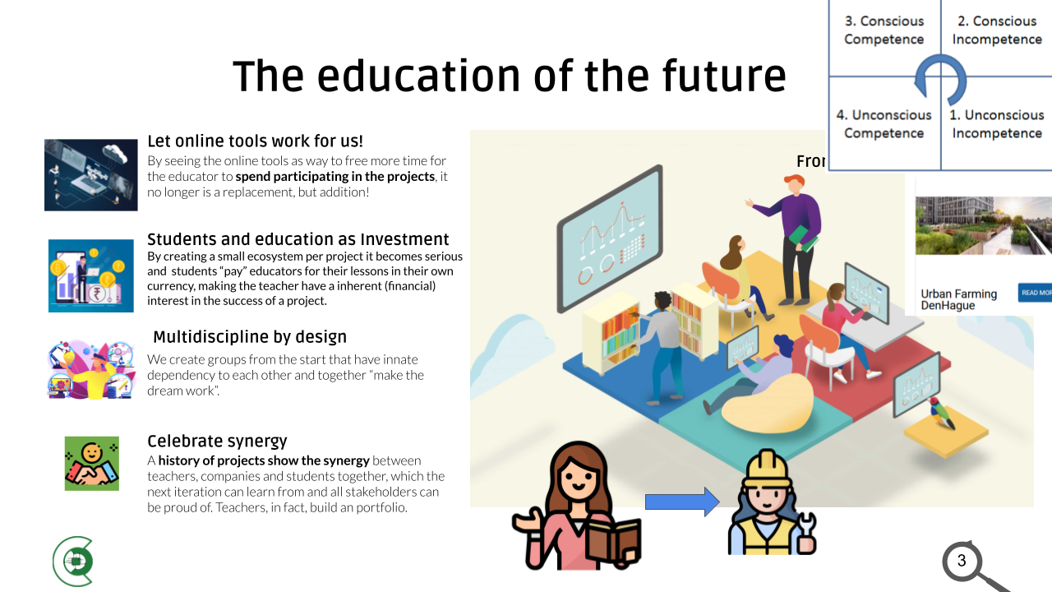

Recruitment Strategy

Our recruitment strategy focuses on diverse talent acquisition by offering realism-centric workshops, specialized classes, and insightful guest lectures. These educational initiatives are supported by a dynamic social media campaign emphasizing practical knowledge. We also actively engage with unconventional networks, such as DevCon, CCC, and LAG, to connect with radical thinkers and provide a platform for open expression. This approach helps us attract 'Crazy Professors and Alternative Thinkers' who bring creativity and critical thinking to our team, essential for driving innovation

Onboarding and Offboarding

Members (which include students) join VCR for a limited period, usually 6 months (an internship). We do not onboard or offboard members, just for a specific project, **so students don’t need to have a specific project ready,** to join. This does not just insure honest commitment to projects from members (preventing students from just “forcefully” selecting a project) but also flow trough the organisation, as well as training opportunities. Additionally, this will make projects created with VCR independant from it’s founding members, least projects tend to stop or lose sigificant momentum at each major cycle.

Educational Justification Note: At Value Chain Rebels, students are immersed in a unique learning environment where they function as "lab members." Unlike traditional educational settings, here they engage in projects with a dynamic approach, akin to real-world labs, software development agencies, or consultancy firms. This hands-on experience allows them to develop skills as independent researchers, innovators, and project managers, even though they may participate in varying numbers of projects, mirroring the unpredictability of professional scenarios.

Our onboarding ensures new members are ready and integrated from the start. It includes clear pre-start communication, an immersive introduction to our mission and team, customized skill training, mentorship for support and growth, and project alignment to match interests and expertise.

*Potential Partners are currently, Hogeschool Utrecht, 2Tokens, Toekomst school, To drive sustainability we need to improve value chains. To improve value chains we need to mobilize willing consortia. To create willing consortia we need the drive of changemakers. Students often want to be the changemaker but do not know how. For students to be effective they need access to knowledge, support and guidance. VCR develops the support mechanism to turn students into effectively taking up this role of changemaker. VCR supports access to knowledge, onboarding programs and community building*

*>> Creer de omgeving waar studenten kunnen triven om de supplychains te herorganiseren.*  
*> Wat we voor ogen hebben om te om de Supplychains te veranderen (Met studenten)*  
*> Samenwerkings positie*  
*> Cyclus het onboarden, managen, en offboarden van studenten. Wat hebben wij als mechanmisme voor nodig. Om de ketens te verbeteren.*   
*> tools, AI.*

*How do I find Problems, How do I contract it, How do I tackle it, and how do we make sure projects survive. >> Translate everything to Buttel points.*

* *Problem Definition : How do we find problems: Why did we take PFAS*
* *How are we going to Organize this: How does this look like*
* *How do we ensure that within 6 months a group of students and experts to get a successful project*

*Note: Pay extra attention to the structure of the Chapter, What are the minimum core things > 10 bullet points what the strategic plan is.*

*“We don’t want to tackle problems alone so that we can put students in the driving seat.*  
*How do we find the problems > Fase 2: How do we organize it that the problem is tackled the best, how does that look like.*

### Integration of Sustainability Metrics as a solution metric

Develop and integrate Long-Term Vision

VCR envisions a future where global supply chains are not only efficient and profitable but also resilient, upcycling, and ethical. By adding extra value through upcycling and good practices, VCR aims to create a ripple effect that transforms global supply chain dynamics, making sustainability a cornerstone of business operations worldwide. Through collaboration, innovation, and advocacy, VCR is dedicated to leading this transformative journey, ensuring that supply chains contribute positively to the planet and its people for generations to come."

# ANNEX A

Formula for Prioritizing Upcycling Supply Chains

Given the complexity and variability of supply chains, a composite score can be calculated using available ESG metrics. This score can help VCR identify which supply chains have the greatest potential for sustainability improvements. The formula integrates three main components: Environmental Impact (EI), Social Responsibility (SR), and Governance Quality (GQ).

Step 1: Identify Data Sources

Environmental Impact (EI):

Data Source: Corporate sustainability reports, environmental impact databases like the Global Reporting Initiative (GRI) database, and environmental data platforms such as the Carbon Disclosure Project (CDP).

Metric: Carbon emissions (CO2e), water usage, waste generation.

Social Responsibility (SR):

Data Source: Social responsibility indices, labor rights organizations' reports, and corporate social responsibility (CSR) sections in annual reports.

Metric: Employee welfare scores, community impact assessments, supply chain labor practices.

Governance Quality (GQ):

Data Source: Governance reports, ESG rating agencies (e.g., MSCI, Sustainalytics), and public disclosures on corporate governance practices.

Metric: Board diversity, anti-corruption measures, ethical sourcing policies.

Step 2: Calculate Composite Sustainability Score (CSS)

The Composite Sustainability Score (CSS) for each supply chain can be calculated by weighting and summing the normalized scores of the three components:

Where:

CSS is the Composite Sustainability Score

w_EI, w_SR, w_GQ represent the weightings assigned to each component (Environmental Impact, Social Responsibility, Governance Quality) based on VCR's strategic priorities. You will replace these with the specific weight numbers you've assigned.

EI_score, SR_score, GQ_score are the normalized scores for each component, calculated from your data sources. These scores should be normalized to a scale from 0 to 1.

Step 3: Prioritize Supply Chains

Supply chains with higher CSS indicate a greater potential for sustainability impact and improvement. VCR can prioritize these supply chains for interventions, partnerships, and sustainability projects.

Implementation

**Data Collection**: Gather data for EI, SR, and GQ from the identified open sources for each supply chain under consideration.

**Normalization and Scoring**: Convert the collected data into normalized scores on a scale from 0 to 1.

**Weighting and Calculation**: Apply the formula to calculate the CSS for each supply chain.

**Prioritization**: Use the CSS to identify and prioritize supply chains for sustainability initiatives.

Approach Using Trase and Vizzuality Data

Objective

To evaluate supply chains based on their environmental sustainability, focusing on indicators such as deforestation, greenhouse gas emissions, and the sustainability of commodity trade.

Data Sources

**Trase (Transparency for Upcycling Economies)**: Provides insights and analysis on the sustainability of commodity trade, including data on deforestation linked to specific commodities and supply chains.

**Vizzuality**: Offers datasets and software tools that map supply chains and calculate the impacts of environmental indicators, including deforestation and greenhouse gas emissions.

Formula for Evaluating Supply Chain Sustainability (SCS)

T evaluation can be based on key indicators such as deforestation risk and greenhouse gas (GHG) emissions associated with a supply chain. The formula could look like this:

SCS=1 / Deforestation Risk Score+GHG Emissions Score​

Where:

**Deforestation Risk Score (DRS)**: Derived from **Trase**, measures the risk of deforestation associated with a particular supply chain or commodity. The higher the score, the higher the risk.

**GHG Emissions Score (GHGES)**: Calculated based on data from **Vizzuality** or similar sources, represents the total GHG emissions associated with the supply chain. The higher the score, the higher the emissions.

Implementation Steps

**Identify Supply Chains**: Select the supply chains you wish to evaluate, focusing on those critical to your operations or those in regions known for environmental risks.

**Collect Data**:

Use Trase to gather data on deforestation risk associated with your selected supply chains.

Utilize Vizzuality’s datasets or similar tools to assess the GHG emissions of these supply chains.

**Calculate Scores**:

Assign a Deforestation Risk Score based on the extent of deforestation risk identified.

Assign a GHG Emissions Score based on the total emissions calculated.

**Evaluate SCS**: Apply the formula to each supply chain to determine its Sustainability Score. Lower scores indicate higher sustainability potential due to lower deforestation risks and GHG emissions.

**Prioritize**: Supply chains with the lowest combined risk and emissions scores should be prioritized for sustainability initiatives, as they represent the best opportunities for impactful environmental improvements.

Approach for Identifying Suboptimal Supply Chains

Objective

To identify suboptimal supply chains where the introduction of good practices can enhance efficiency, reduce waste, and lower costs, with sustainability improvements as a natural consequence.

Data Sources and Metrics

**Operational Efficiency**: Look for data indicating long lead times, high variability in supply chain processes, and low inventory turnover rates.

**Data Source**: Industry reports, company financial reports available on platforms like EDGAR (for US companies), and supply chain management journals.

**Waste Levels**: Identify supply chains with high levels of waste, including excess inventory, high defect rates, and significant unused resources.

**Data Source**: Sustainability reports published by companies, research articles, and databases like the Global Reporting Initiative (GRI).

**Cost Metrics**: Focus on supply chains with high operational costs relative to industry benchmarks, including logistics costs, inventory carrying costs, and cost of quality.

**Data Source**: Industry benchmark reports, open financial databases, and logistics studies.

Formula for Identifying Suboptimal Supply Chains (ISC)

To quantify the suboptimality of a supply chain, we can use a composite score that considers efficiency, waste, and cost metrics:

Where:

W1,W2, ​ W3 are the weightings assigned to each metric based on their perceived impact on supply chain performance.

Each score is normalized on a scale from 0 (optimal) to 1 (highly suboptimal).

Implementation Steps

**Data Collection**: Gather data for the selected metrics from the identified sources for each supply chain under consideration.

**Score Calculation**:

**Operational Efficiency Score**: Higher scores for longer lead times and lower inventory turnovers.

**Waste Level Score**: Higher scores for higher levels of waste and defects.

**Cost Metric Score**: Higher scores for costs significantly above industry benchmarks.

**Evaluate ISC**: Apply the formula to calculate the ISC for each supply chain. Higher scores indicate supply chains that are more suboptimal and, therefore, have greater potential for improvement through the implementation of good practices.

**Prioritize**: Supply chains with the highest ISC scores should be prioritized for interventions. These are the supply chains where improvements in efficiency, waste reduction, and cost management can significantly increase value and lead to sustainability benefits.

ANNEX B:  
  
**Operational Plan Overview**

Strategic Planning and Decision Making

**Objective**: To steer VCR towards achieving its mission through effective strategy and decision-making.

**KPI**: Achievement rate of strategic goals within the set timeframe.

**Function**: Guides the overall direction and strategy of VCR, integrating sustainability deeply into supply chain operations.

**Key Roles:**

**Executive Director**: Sets strategic priorities and leads the organization.

**Strategy Analysts**: Conduct market and sustainability trend analyses to inform strategic decisions.

**Tasks**:

Develop and periodically review the strategic plan.

Identify and prioritize areas for sustainability impact within supply chains.

Research and Development (R&D)

**Objective**: To innovate and develop solutions that enhance the impact of good practices in supply chains, thereby transforming them into models of sustainability and efficiency.

Key Roles

R&D Director: Leads the R&D department, setting research priorities that align with VCR's mission to enhance the impact of good practices in supply chains.

Sustainability Research Scientists: Conduct research focused on identifying, developing, and refining good practices that can significantly improve supply chain sustainability.

Innovation Engineers: Design and prototype technologies and methodologies that operationalize research findings into practical solutions for supply chains.

Project Managers (R&D): Oversee R&D projects from inception through completion, ensuring they stay on track, within budget, and achieve desired outcomes.

Tasks

Research Identification: Identify areas within supply chains where the introduction or enhancement of good practices could lead to significant sustainability improvements.

Solution Development: Develop innovative solutions and methodologies that can be implemented in supply chains to promote good practices, reduce environmental impact, and improve efficiency.

Prototyping and Testing: Prototype new technologies and processes, and conduct rigorous testing to ensure effectiveness and scalability.

Collaboration and Knowledge Sharing: Collaborate with academic institutions, industry partners, and other stakeholders to share knowledge, gather feedback, and refine solutions.

KPI

Number of Innovative Solutions Developed: Track the number of new solutions and methodologies developed each year that aim to enhance the impact of good practices in supply chains.

Impact of Implemented Solutions: Measure the tangible impact of implemented solutions on supply chain sustainability, efficiency, and resilience. SEE CSS SCS ICS -> ANNEX A

Adoption Rate by Industry Partners: Monitor the rate at which industry partners adopt the developed solutions, indicating the practical applicability and value of R&D outputs.

Publications and Patents: Count the number of research publications and patents filed, reflecting the innovative output and thought leadership of the R&D function.

Education and Outreach

Objective: To raise awareness and educate stakeholders on upcycling supply chain practices.

KPI: Engagement level of educational programs and outreach initiatives.

Partnership Development

Objective: To build strategic partnerships that enhance VCR's impact and resource base.

KPI: Number of strategic partnerships formed.

Technology and Innovation

Objective: To leverage technology in advancing sustainability within supply chains.

KPI: Implementation rate of new technologies in supply chain projects.

Funding Acquisition

Objective: To secure financial resources to support VCR's mission and projects.

KPI: Total funds raised versus target.

Operations and Project Implementation

Objective: To execute sustainability projects effectively within supply chains.

KPI: Success rate of implemented sustainability projects.

Policy Advocacy

Objective: To influence policy in support of upcycling supply chain practices.

KPI: Number of policy changes influenced or initiated.

Human Resources and Administration

Objective: To support VCR's operational needs and ensure a motivated, engaged team.

KPI: Employee satisfaction and retention rate.

### Promotion of Labor Practices (in the style of FORD)

Simulate and talk about the effect of good practices across all supply chain levels. By ensuring fair wages, safe working conditions, on-time payments and respect for workers' **ford** showed us that output can increase and you can turn it into a significant advantage. We need to make sure that there are economic drivers to do ethical practices, otherwise we break “The social contract”. The story of Henry Ford illustrates exactly the paradigm of supply chain, hailed as an innovator for upcycling business practices, not a lot of people pay attention to the fact that he didn’t do it to be in the “moral right”. He did it, because it was an economic opportunity, and he did it, cold and calculating. He did it, to add more value to his products, his company, his consumer’s lives but especially to his bottom line.

Circular Economy Adoption (in the style of ROCKERFELLER)

Facilitate the transition towards a circular economy by encouraging the reuse, recycling, and repurposing of materials **and how this can be used for profit**. Use examples like Rockefeller and the “Queen of Trash” Zhang Yin. This effort seeks to minimize waste and promote the regeneration of natural systems, trough basic economics, thereby adding value to the supply chain while protecting the planet.

Technology-Driven accountability (in the style of the VOC)

Utilize advanced traceability technologies to bolster accountability within supply chains. This strategy empowers both consumers and businesses to hold entities accountable for their commitments and to their word. By ensuring that every step of the supply chain can be audited and verified, upcycling finance can start to take hold. By making the rules semi-equal for everyone, we can allow the supplychain dynamics to make the supplychain more stable and profitable.

Effectively VCR can become a 3rd party neutral distributor of supplychain software.

Collabortive Innovation Platforms (in the style of a Library)

Create education and information exchange between businesses, innovators, and researchers and specifical research institutions to develop new solutions for supply chains. These platforms will serve as incubators for ideas that can revolutionize supply chain practices, focusing on sustainability and social good. They should work as a traditional library, where you can come in and find information*, there might be someone to help you*, but the idea is that you can find it yourself, explore by yourself, and that each book, *should* do its own job of explaining itself.

ANNEX C:

|  |  |  |
| --- | --- | --- |
| Digital Tools and Platforms | Trello | Visual project management tool for organizing tasks and projects. |
| Digital Tools and Platforms | Asana | Project management software for team collaboration. |
| Digital Tools and Platforms | Jira | Project tracking tool for software development projects. |
| Digital Tools and Platforms | Amazon Web Services (AWS) | Scalable cloud computing services. |
| Digital Tools and Platforms | Google Cloud Platform | Cloud computing services for storage and computing power. |
| Digital Tools and Platforms | Microsoft Azure | Cloud computing service for building |
| Data Analytics Platforms | Apache Hadoop | Framework for distributed storage and processing of big data sets. |
| Data Analytics Platforms | Spark | Fast and general engine for big data processing. |
| Data Analytics Platforms | R | Statistical computing and graphics software. |
| Data Analytics Platforms | Python with Pandas and NumPy | Programming language with libraries for data analysis and manipulation. |
| Data Analytics Platforms | SPSS | Software for statistical analysis. |
| Data Analytics Platforms | Stata | Statistical software for data analysis |
| Data Analytics Platforms | Tableau | Data visualization tool for business intelligence. |
| Data Analytics Platforms | Power BI | Business analytics service for data visualization. |
| Data Analytics Platforms | Google Data Studio | Data visualization and reporting tool. |
| Global Research Networks Access | Google Scholar | Search engine for scholarly literature. |
| Global Research Networks Access | Web of Science | Comprehensive research platform. |
| Global Research Networks Access | Scopus | Abstract and citation database of peer-reviewed literature. |
| Global Research Networks Access | arXiv | Open access repository of scientific papers. |
| Global Research Networks Access | PubMed Central | Free full-text archive of biomedical and life sciences journal literature. |
| Global Research Networks Access | SSRN | Repository for research in the social sciences and humanities. |
| Training and Development | Coursera | Online learning platform offering courses from universities and colleges. |
| Training and Development | edX | Online learning platform offering courses from universities and colleges. |
| Training and Development | LinkedIn Learning | Online learning platform offering video courses taught by industry experts. |
| Training and Development | GoToWebinar | Tool for hosting webinars and online seminars. |
| Training and Development | WebEx | Video conferencing tool for webinars and online meetings. |
| Innovation Incubators | IdeaScale | Idea management software to capture and develop new ideas. |
| Innovation Incubators | Brightidea | Innovation management platform to collect and implement ideas. |
| Innovation Incubators | Adobe XD | Tool for designing |
| Innovation Incubators | Figma | Interface design tool with real-time collaboration. |
| Innovation Incubators | InVision | Prototyping and collaboration tool for designers. |
| Sustainability Integration | Siemens Building Technologies | Energy management systems for optimizing energy use. |
| Sustainability Integration | Honeywell Building Solutions | Technology and services for upcycling building operations. |
| Sustainability Integration | Waste Management Software | Software for efficient waste handling and recycling. |
| Sustainability Integration | RecycleTrack Systems | Technology-driven waste and recycling management service. |
| Ethical Research Practices | IRBNet | Web-based solution for research ethics compliance. |
| Ethical Research Practices | Mentor IRB | Ethics compliance software for managing research ethics submissions. |
| Ethical Research Practices | ProtonDrive | Secure cloud storage service for data protection. |
| Ethical Research Practices | Tresorit | Secure cloud storage for confidential documents and data. |
|  |  |  |
|  |  |  |
|  |  |  |
| ANNEX G:  ANNEX D: |  |  |
|  |  |  |
|  |  |  |
|  |  |  |
|  |  |  |

1. comprehensive metrics into supply chain operations which are to be used to select projects **ISC SCS CSS** [See Annex A], enabling businesses to measure and understand their environmental impact accurately and enabling VCR to select projects with the most potential impact. This initiative aims to make sustainability a quantifiable and actionable goal within supply chains.
2. comprehensive metrics into supply chain operations which are to be used to select projects **ISC SCS CSS** [See Annex A], enabling businesses to measure and understand their environmental impact accurately and enabling VCR to select projects with the most potential impact. This initiative aims to make sustainability a quantifiable and actionable goal within supply chains.
3. comprehensive metrics into supply chain operations which are to be used to select projects **ISC SCS CSS** [See Annex A], enabling businesses to measure and understand their environmental impact accurately and enabling VCR to select projects with the most potential impact. This initiative aims to make sustainability a quantifiable and actionable goal within supply chains.